**TASK: A**

**Investigate basic security principles and standards**

**TASK: A.1**

**Verify basic security principles and standards**

As a cloud security engineer at Global Electronic Services (GESC), it is essential to understand the core security principles and standards that shape the defense mechanisms of our cloud infrastructure. The importance of these standards extends beyond simply adhering to them; they are integral to instilling a security culture spread throughout the organization, ensuring strong protection against a wide range of cyber threats.

**Importance and purpose of security standards**

In today's digital age, organizations are often targeted by cybercriminals motivated by financial gain or geopolitical advantages. This reality poses a significant threat, especially for small and medium-sized businesses that often lack the financial resources to hire a dedicated team of cybersecurity experts. For SMBs, adopting cybersecurity standards is not just a strategic defensive tactic – it's a survival strategy.

**Why following security standards is critical**

The question of why cybersecurity standards are important leads to an understanding of their essential and most beneficial role for organizations. These standards significantly improve the security posture of the organization without the need for expensive new technologies. While the goal of cybersecurity standards is to prevent attacks, it is also important to be aware of the occurrence of breaches. Adhering to these standards can mitigate such incidents. Standards often require organizations to have incident response policies in place, providing reassurance to users and stakeholders that the organization is well prepared to deal with and mitigate incidents efficiently.

**Adherence to standards can lead to:**

* Reduce risk by providing a framework for identifying, assessing, and managing security threats and vulnerabilities.
* Reduce insurance premiums by demonstrating that the organization has taken reasonable steps to protect its assets and data.
* Ensure legal compliance by following regulations and laws such as the General Data Protection Regulation (GDPR) or the Payment Card Industry Data Security Standard (PCI DSS).
* Build trust and reputation by showing that the organization values security and respects the privacy of stakeholders.
* Facilitate the exchange of knowledge and best practices by improving understanding and communication among security professionals.

**Purpose of adhering to these standards**

The main purpose of following security standards is to protect the organization's information and systems from cybersecurity threats and risks. These standards provide guidance, best practices, and requirements for implementing security controls and processes that can prevent or mitigate cyberattacks. By adhering to these standards, the organization can also demonstrate compliance with legal and contractual obligations, reinforcing its commitment to protecting the data of its customers and partners.

**Following these standards helps the organization to:**

* Identify and manage assets, threats, vulnerabilities and risks by assessing the potential impact and likelihood of incidents.
* Identify and implement appropriate security controls and measures, such as policies, procedures, techniques and training, to reduce risk to an acceptable level.
* Monitor and review the effectiveness and performance of its security procedures, and make improvements as necessary based on feedback and audits.

**How compliance with these standards enhances overall system security**

Compliance with security standards is a strategic necessity for organizations that aim to comprehensively enhance their cybersecurity posture. These standards provide a structured framework for guidelines, best practices and mandatory requirements, to serve as a roadmap for strengthening defense mechanisms. The multifaceted benefits of adhering to these standards go beyond regulatory requirements and contribute significantly to the overall resilience of the organization.

One of the primary advantages is to protect the reputation of the organization and maintain the trust and loyalty of customers. Demonstrating a clear commitment to security by complying with these standards enhances trust among the customer base, which is a valuable asset pivotal in maintaining business relationships and attracting new business opportunities.

Compliance provides a competitive advantage. Meeting or exceeding the expectations of customers, business partners and regulators accelerates the sales cycle and strengthens the organization's position in the market. It illustrates the organization's dedication to security, which can be a decisive factor in the decision-making processes of potential clients and partners.

A deeper dive into the technical aspects reveals that compliance initiatives lead to improvements in the organization's technological infrastructure and processes. By applying recognized security best practices, organizations lay a strong foundation for effectively managing threats and vulnerabilities. This not only enhances the organization's security posture, but also enhances the security culture and compliance awareness among employees.

The importance of compliance extends to the legal and regulatory landscape. Organizations must navigate a complex network of requirements, and compliance with security standards ensures compliance with commercial, legal, contractual and regulatory obligations. This alignment protects the organization from legal complexities and potential liabilities, contributing to overall risk management.

The systematic and proactive approach advocated by security standards is often organized around the planning, implementation, verification and implementation (PDCA) cycle. This approach allows organizations to continuously improve their Information Security Management Systems (ISMS) by identifying, assessing, and mitigating information security risks. The course focuses on the continuous monitoring, measurement, analysis and evaluation of the performance of the information management system, ensuring a dynamic and responsive security framework.

Internal audits and management reviews, as stipulated in the Security Standards, are critical elements of the compliance journey. These processes provide organizations with insights into the effectiveness of their security measures, enabling them to identify areas for improvement and implement corrective actions immediately.

It is equally important to focus on the competence, awareness and training of employees in the context of an Information Security Management System (ISMS). Security standards recognize the human factor as a critical element in maintaining a safe environment. By ensuring that employees are well versed in security protocols and procedures, organizations reduce the likelihood that human error will turn into a major security vulnerability.

Documentation is the cornerstone of security standards, providing details of the information required by the standard and the organization's information management system. The creation, approval, distribution, use, protection, retention and disposal of these documents contributes to the overall management of information within the organization.

Since compliance with security standards undoubtedly provides numerous benefits, it is necessary to emphasize that compliance is the baseline, not the destination. Organizations must aspire to cultivate a security-oriented culture that goes beyond compliance requirements. This implies an ongoing commitment to improving security practices, adapting to emerging threats, and promoting a resilient cybersecurity posture capable of facing the evolving threat landscape.

**TASK: A.2**

**NIST SP 800-53 Rev. 5**

NIST SP 800-53 Rev. 5 is more than just a set of guidelines; it is a comprehensive framework designed by the National Institute of Standards and Technology (NIST) to protect federal information systems across the United States. Although it is primarily designed for government use, its rigorous and adaptable nature makes it a valuable asset for private companies managing government data or those looking for a structured approach to cybersecurity. This standard allows organizations to tailor their security measures to suit their specific needs, taking into account unique risks, business processes, and technological environments. It integrates cybersecurity and privacy controls, providing a holistic approach to addressing the myriad cyber threats faced by modern organizations.

**ISO/IEC 27001**

ISO/IEC 27001 is not just a regulatory requirement; it is a strategic framework that offers organizations around the world a proven methodology for protecting sensitive information. This standard helps businesses of all sizes and types systematically secure their data through an Information Security Management System (ISMS) that integrates people, processes, and technology. The globally recognized ISO/IEC 27001 standard helps organizations not only protect critical business information but also effectively manage and reduce security risks. They are especially valuable for companies that want to demonstrate their serious commitment to information security, whether to enhance customer trust or comply with regulatory requirements.

**Here are some comparisons between both standards:**

|  |  |  |  |
| --- | --- | --- | --- |
| Standard | Range | Benefits | Restrictions |
| ISO 27001 | ISO/IEC 27001 is an international standard that specifies requirements for the establishment, implementation, maintenance and improvement of an Information Security Management System (ISMS) on an ongoing basis. This applies to any organization, regardless of its size or field of business, looking to manage the security of assets such as financial information, intellectual property, employee details, or information entrusted to a third party. | **ISO/IEC 27001 is** internationally recognized, enhancing the credibility of the organization globally.  **Risk management** provides a structured approach to managing a company's sensitive information, ensuring it remains secure through risk management processes.  **Adaptability** This standard is flexible and can be adapted to suit the specific security needs of any organization.  It can **improve** my infrastructure and technical processes by implementing security best practices and creating a culture of security and compliance.  It can give me a competitive advantage over non-compliant competitors and speed up the sales cycle. | 1. Costly certification process: Obtaining and maintaining ISO/IEC 27001 certification can be costly. The process includes initial setup costs, audit fees, and ongoing costs related to continuous improvement and recertification audits. 2. Implementation complexity: Although ISO/IEC 27001 is flexible, designing and implementing an Information Security Management System (ISMS) that complies with the standard can be complex and time-consuming. This complexity often requires outside consultants or specialized staff, which can increase costs and prolong setup time. 3. General framework: Although its broad-scale applicability is a strength, the general nature of ISO/IEC 27001 can also be a limitation. Organizations may find that the standard does not provide sufficient guidance on specific technologies or industry-specific challenges. 4. The organization has to create, implement, maintain and continuously improve the information management system, following the Plan-Do-Verify-Act (PDCA) cycle. 5. Reliance on internal discipline: The effectiveness of ISO/IEC 27001 depends heavily on the organization's commitment and internal discipline to maintain an Information Security Management System (ISMS). Without strong internal governance and commitment, achieving the desired security outcomes can be challenging. |
| NIST SP 800-53 Rev. 5 | NIST SP 800-53 Revision 5 provides a comprehensive set of security and privacy controls for federal information systems and organizations and aims to improve security for all organizational processes and assets, whether part of the physical or digital world, or both. They are particularly relevant to government agencies and contractors in the United States, but can also be widely applied in the private sector, especially by companies that work with government data. | **Flexibility and comprehensiveness:** This standard is adaptable, offering a wide range of security controls that can be tailored to the specific needs of the organization. It covers everything from access control to incident response and system protection and communications.  **Focus on privacy:** Version 5 emphasizes the integration of privacy into its controls, making it one of the first programs to actively build privacy into a cybersecurity framework.  **Durability:** Designed to address a variety of modern security requirements, considering the risks posed by cyber threats in a comprehensive manner.  Helps organizations enhance  **their risk management procedures** and reach their security and privacy goals. | * Complexity: NIST SP 800-53 Rev. 5 features a comprehensive and wide range of controls, which can be overwhelming and complex for organizations, especially small or new ones in strict security frameworks. * Resource intensity: Implementing and maintaining the controls described in NIST SP 800-53 requires significant resources in terms of time, personnel and financial investment, making it difficult for organizations with limited budgets. * Focus on the United States: While the NIST SP 800-53 can be adapted for use in the private sector and internationally, its primary design and focus is on U.S. federal agencies and contractors. This focus may limit its applicability or direct relevance to organizations outside the context of the U.S. federal government. * Dynamic update requirements: The rapidly evolving nature of cyber threats means that the standard needs frequent updates to remain relevant. Organizations may find it difficult to keep up with these updates and ensure that their systems remain compliant. * Technical Demand: The implementation of NIST SP 800-53 Rev. 5 requires a high level of technical expertise, which may require extensive training or the recruitment of specialized personnel, increasing organizational cost and operational complexity. |

**Analyze how each standard contributes to ensuring the security of cloud-based systems**

**How NIST SP 800-53 Rev. 5 Contributes to the Security of a Cloud-Based System**

**NIST SP 800-53 Rev. 5 is particularly suitable for cloud environments due to its comprehensive and adaptable nature. Here's how to contribute to the security of cloud-based systems:**

**Robust framework:** NIST SP 800-53 offers a detailed and extensive range of controls specifically designed to address a wide range of security and privacy concerns. For cloud systems, this means they offer specific guidance on everything from identity management and access to incident response and recovery.

**Flexibility:** One of the notable features of the NIST SP 800-53 is its flexibility. Organizations can tailor controls to their specific needs based on the sensitivity of the data they handle and their exposure to different risks. This is critical in cloud environments where the degree of control of physical infrastructure varies.

**Risk Management:** This standard emphasizes a risk management approach, encouraging organizations to continuously assess and address their security vulnerabilities. This ongoing process is vital for cloud systems, as new vulnerabilities can quickly emerge due to the dynamic nature of cloud computing.

**Privacy and security integration:** By integrating privacy controls within the cybersecurity framework, NIST SP 800-53 ensures that organizations comprehensively address both security and privacy – a critical consideration because cloud systems often store and process vast amounts of personal data.

**Scalability:**  The scalable nature of NIST SP 800-53 makes it ideal for cloud systems that may need to scale or change quickly. Security controls can be scaled up or down based on cloud deployment size and complexity, ensuring that security measures are always appropriate and effective.

**How ISO/IEC 27001 contributes to cloud-based system security**

**ISO/IEC 27001 also plays a pivotal role in enhancing the security of cloud-based systems through its structured approach to information security management:**

**Systematic risk management:** ISO/IEC 27001 is centered around a risk-based approach to security management, requiring organizations to systematically identify, analyze and address risks. In cloud environments, this means ensuring that all potential vulnerabilities are covered, from data breaches to unauthorized access.

**Continuous improvement:** The standard requires continuous review and improvement of the Information Security Management System (ISMS), which is critical for cloud systems to adapt to threats and new changes in technology. This dynamic process helps organizations stay ahead of potential security issues.

**Third-party management:** ISO/IEC 27001 requires strict management of third-party engagements, which include cloud service providers. This ensures that data processed by third parties is subject to the same level of security as internal operations, which is an essential aspect given the reliance on third-party services in cloud computing.

**Accreditation and trust: Obtaining** ISO/IEC 27001 certification can be a mark of confidence for stakeholders, indicating that the organization adheres to internationally recognized security management practices. For cloud-based systems, this certification can significantly boost customer and partner trust.

**Comprehensive security controls:** The standard provides a framework for implementing comprehensive security controls that apply to different aspects of cloud security, including access controls, data encryption, and physical and environmental security.

**Comparison and integration**

NIST SP 800-53 Rev. 5 and ISO/IEC 27001 offer frameworks that are not only comprehensive, but also integrated. While NIST provides a more detailed set of controls suitable for complex and high-risk environments such as government data in the cloud, ISO/IEC 27001 offers a more general framework that applies to a wide range of industries and can help create a robust ISMS system that includes cloud security.

Organizations operating cloud-based systems can benefit from adopting both standards to ensure a comprehensive approach to security. This dual approach allows them to leverage NIST's detailed control catalog alongside ISO management systems to create a secure, compliant, and resilient cloud environment.

**TASK: A.3**

In the complex world of cloud security, coordinated collaboration between different security standards, including ISO/IEC 27001,NIST SP 800-53, security interferences for CSA (Cloud Control Matrix),PCI DSS,FedRAMP, andGDPR, weaves a multi-faceted framework to the level of ensuring email to the cloud to new heights. Here's a detailed analysis of the importance of integrating security standards into cloud secret intelligence development, using the case study of Actfile, the cloud data security platform.

**Comprehensive security management in accordance with ISO/IEC 27001**

ISO/IEC 27001 certified as a central hub in this complex, where a comprehensive information technology system (ISMS) was initiated. This system does not enable many, many, but also has a light multivariate mechanism. The synergy between ISO/IEC 27001 and NIST SP 800-53, which extends in the presentation of a catalogue of controls for security ducks, takes security measures and breadth — available from access control, encryption and even always for incidents.

**Enhance cloud service security with CSA and PCI DSS**

The necessity of having a CSA cloud control matrix requires accurate supply of various cloud security services. Next, PCI DSS intervenes to activate the processing of push data – a part that is not part of the dynamic attack scenario. This data collectively and fundamentally relies heavily on transactions and data integration across cloud core data.

**Government data protection measures with FedRAMP and GDPR**

FedRAMP bears the weight of this collaborative effort by delivering security standards that resonate well with cloud providers that meet impassable government requirements. At the same time, he takes responsibility for public data, although it is not a strict technical standard, since he returns from the degrees of data protection, allowing him to go out with the wider and in this due to collaboration. Its focus on individual privacy and data handling practices is echoed through this symphony of collaboration, emphasizing the importance of animal data management and responsibility in cloud environments.

**A case study in the implementation of Actfile legal standards :**

Actfile, founded by Guy Paveley and Assaf Leital in 2017, realized it had to fall short of traditional solutions to block strong data (DLP) in opposition to liberalism and the diverse nature of rejecting today's belated economic relations. Inefficient local technology for monitoring traffic files, analyzing content, and encrypting sensitive data. Actfile's mission area is to provide a strong cybersecurity foundation that allows businesses to grow and on them fully.

**Actfile server** primarily in the U.S. Small Size Businesses (SMBs) at the forefront of managed services (MSPs), who work in external IT departments. By adopting ISO 27001, Actfile has pledged to protect data and not have no special data laws and regulations, such as HIPAA, NIST,GDPR, ANDPDPA.

**The multifaceted importance of security standards in Actfile's cloud infrastructure**

**Enhanced data protection:** The application of standards such as ISO 27001 ensures a systematic approach to information security management. For Actfile, this translates into enhanced protection for sensitive data for the self-employed and those working in the gig business economy, boosting trust in the platform.

**Regulatory Compliance:** Compliance with security standards is critical to compliance with industry regulations. For Actfile, this means compliance with data protection laws, which is a critical aspect given the sensitivity of the information being handled.

**Risk mitigation and resilience:** Security standards provide a framework for identifying, assessing and mitigating security risks. For Actfile, this proactive approach to risk management contributes to the resilience of its cloud infrastructure, reducing the likelihood and impact of potential security incidents.

**Building customer trust:** Security standards act as a confidence-building mechanism. With ISO 27001 certification, Actfile sends a clear message to its user base that their data is handled with the highest security standards, retaining existing customers and attracting new customers prioritizing robust security measures.

**Competitive advantage:** In a competitive marketplace, compliance with security standards gives Actfile a distinct competitive advantage. ISO 27001 certification is a clear mark that distinguishes Actfile, assuring customers that the platform goes the extra mile into ensuring data security and privacy.

**Scalability and future verification:** Security standards often include guidelines for scalable architecture. For Actfile, this means being able to seamlessly scale and scale its cloud infrastructure while maintaining a strong security posture.

**Incident Response and Recovery:** Safety standards provide guidance for incident response and recovery. In the event of a security incident, Actfile can rely on a systematic approach to minimize damage, recover quickly, and learn from the incident to enhance its security measures.

**Vendor and Partner Guarantee:** Compliance with security standards reassures Actfile partners and vendors about collaborative ecosystem security. This is particularly critical in the cloud where multiple entities interact, ensuring collective adherence to security best practices.

**Enhance interoperability and integration**

**Interoperability between diverse systems:** Security standards such as those mentioned facilitate interoperability between different cloud services and platforms. This is critical as it ensures that data can be shared and processed securely across diverse systems without compromising security.

**Simplified integration:** By adhering to established security frameworks, organizations can simplify the integration of new services and technologies. Security standards provide common language and standards, reducing the complexity and potential security risks associated with integrating disparate systems.

**Strategic security planning and long-term sustainability**

Strategic Security Compatibility: Security standards help align security strategies with business goals. This alignment ensures that security measures are not only technically effective, but also strategically enhance business operations, contributing to the overall objectives of the organization.

**Sustainability through security: The** long-term sustainability of cloud infrastructure relies heavily on strong security practices. By implementing these standards, organizations can protect their systems in the future against evolving threats, ensuring long-term sustainability and reducing the need for frequent and destructive repairs.

**Advanced threat detection and response capabilities**

**Advanced threat detection:** Many security standards emphasize the development of advanced threat detection capabilities. This includes establishing comprehensive monitoring systems that provide real-time alerts about potential security breaches, significantly reducing response time.

**Improved incident response:** Effective incident response mechanisms, as mandated by standards such as NIST and ISO, provide organizations with the ability to handle violations more efficiently. These protocols ensure containment and rapid mitigation, minimizing damage and recovery time.

**Compliance benefits and competitive advantage**

**Beyond compliance:** While meeting compliance is essential, integrating security standards offers benefits beyond just meeting regulatory requirements. It positions the organization as a leader in security and trust, setting it apart in the market as a secure and reliable partner or service provider.

**Marketing advantage:** Security certifications can be powerful marketing tools. They reassure customers and customers of the organization's commitment to protecting their data, often influencing purchasing decisions and fostering stronger business relationships.

**Training and cultural benefits**

**Security awareness and culture:** The application of security standards often includes comprehensive training and awareness programs for employees. This helps build a strong security culture within the organization where each employee understands their role in maintaining security.

**Employee empowerment:** By providing clear guidelines and protocols, security standards empower employees to make informed decisions and take proactive steps towards protecting enterprise and customer data.

**Broader risk management framework**

**Comprehensive risk management:** Security standards typically provide a framework not only for technical security measures but also for managing overall security-related business risks. This includes legal, operational and reputational risks, providing a comprehensive approach to threat management.

**Strategic investment in security standards is integral to Actfile's success and sustainability in the cloud services industry. It extends beyond mere compliance, impacting the platform's security posture, customer trust, competitive positioning, and overall readiness to navigate the evolving landscape of the temporary business economy. This symphony of coordinated standards creates a holistic and dynamic approach to cloud security, weaving complex risk management, compliance, data protection, and scalability into the fabric of cloud-based systems.**

**TASK: A.4**

**UnderstandingHash (in Cloud Computing)**

Cryptographic segmentation is an essential technology in cloud computing that serves as an important tool to ensure data security. At its core, hashing is a process that takes an input (or "message") and returns a fixed-size string of bytes that is usually represented as a string of characters. This string is known as hash value or hash code. Think of it as a digital fingerprint of a piece of data; no two different pieces of data have the same fingerprint perfectly.

**The main characteristics of hash functions**

**To be effective, hash functions must exhibit several basic characteristics that make them suitable for security purposes:**

**Determinism**: This means that no matter how many times you hash the same input, you will always get the same hash value. Consistency is critical to validating data integrity over time.

**Fast in computation**: Hash functions must be able to quickly return hash value, making it practical to use in systems where speed is critical, such as in processing large amounts of data in the cloud.

**Pre-image resistance: It** should be computationally incapable of reverse engineering the original input from its hash value. This one-way process helps protect sensitive data, as you can't identify the original information from hashing alone.

**Collision resistance: The** hash function should reduce the chances of having two different inputs producing the same hash value. This uniqueness is vital to ensure that every piece of data can be clearly identified.

**Avalanche effect:** A small change in input data (such as a single character change) should result in a completely different hash. This sensitivity helps detect even the smallest modifications to the data.

**Retail applications in cloud security**

**Retail has a wide range of applications in cloud computing, which include:**

**Data integrity:** Hashing helps verify that data is not altered, destroyed, or tampered with during storage or transit.

Digital signatures: By segmenting documents and then signing them, we can ensure that the documents are original and have not been modified since they were signed.

**Password storage:** Instead of storing passwords directly, systems store password hashes. This way, even if the hash is stolen, it doesn't affect the actual password.

**Blockchain technology:** Each block in the blockchain is linked to the previous block via hashing, creating a secure and immutable record.

**Real-world implementation**

In cloud environments, segmentation acts as a lightweight digital guard. It converts data into hash values using specific algorithms, ensuring a consistent and reliable representation of data regardless of its size. This transformation plays a crucial role in many cloud-based operations:

**Data integrity assurance:** Hashing verifies that data remains unchanged from its original state during transit or storage.

**Deduplication:** In cloud storage, hashing identifies duplicate files through their digital fingerprints, eliminating duplication and saving storage space.

**Data verification:** Before and after data transfer, hashes are compared to ensure that the data is not changed, thus securing the integrity of the data in real time.

**Evolution of retail functions**

Although hash functions such as MD5 and SHA-1 are widely used, they are no longer considered safe for all applications due to vulnerabilities that allow potential collisions. Modern cloud architectures often use stronger hashing functions such as SHA-256 and SHA-3, which provide enhanced and more convenient security features to protect against complex cyber threats.

**Integrate digital certificates into cloud security**

Digital certificates are sophisticated electronic credentials that play a pivotal role in the security architecture of cloud computing. They serve as conclusive evidence of the legitimacy of devices, servers or users, ensuring the reliability of entities involved in digital communications. This section delves into specific types of digital certificates and their applications, particularly in the context of cloud environments such as Amazon Web Services (AWS).

**Types and functions of digital certificates**

**TLS/SSL certificates:** These certificates are essential for secure online interactions, and the establishment of encrypted communication channels between clients and servers. They come in different forms depending on the level of verification required:

**Domain validation:** This is the basic level, and is suitable for any website, where the CA verifies domain ownership. It's fast and releases within minutes, ideal for non-sensitive transactions.

**Organization validation:** This includes lightweight business verification and is preferable for e-commerce sites where a certain level of business legitimacy is essential.

**Extended verification**: The highest level of SSL certificate, requiring comprehensive business verification. This level is critical for large organizations dealing with sensitive data, as it provides the highest degree of trust and security.

**Code signing certificates**: Used by developers to digitally sign their apps and scripts. This certification ensures that the software downloaded or changed by the end user after signing it is not tampered with, preserving the integrity and authenticity of the software.

**Client certificates**: They act as digital identifiers for users or devices, and are commonly used in scenarios such as email communications to authenticate and validate sending parties.

**Role of certification authorities (CAs)**

Certification authorities are trusted entities that issue digital certificates. They verify the credentials of entities requesting certificates and link these credentials to the certificate, providing a digital signature. Certification authorities play a crucial role in managing public keys and ensuring that digital certificates are valid and not compromised. The process involves rigorous checks to validate domain ownership and the legitimacy of the applicant, thus serving as the backbone of online trust.

**Digital Certificates in AWS Cloud Computing**

In a cloud environment like AWS, digital certificates, especially SSL/TLS certificates, are essential to secure data transfers and ensure the integrity and confidentiality of user interactions. AWS leverages these certificates to create secure channels between customers and its servers, ensuring that all data is encrypted in transit and protected from interception or tampering.

**Secure data transfers:** SSL/TLS certificates encrypt data traveling between users and AWS servers, protecting sensitive information as it travels over the Internet.

**Mutual authentication**: AWS supports client certificates for mutual authentication, enhancing security by ensuring that both the client and the server authenticate each other before exchanging any data.

**Code integrity**: For developers deploying applications to AWS, code signing certificates are critical. It ensures that code remains intact and unchanged from its original state, securing applications from unauthorized modifications in a shared cloud.

**Digital certificates form a key layer of security within the cloud computing infrastructure, facilitating a robust mechanism for data protection, user authentication, and software integrity. Their implementation in cloud platforms such as AWS underscores their importance in enhancing security measures, enhancing trust, and ensuring the operational integrity of cloud services. By integrating these certificates, AWS not only secures its platforms, but also provides customers with the tools to effectively protect their applications and data. This strategic use of digital certificates addresses the unique challenges of the cloud environment, fostering a secure, trustworthy, and dependable digital landscape.**

**TASK: B**

**Create a secure cloud and configure security**

**• Secure solution planning in the cloud:**

**TASK: B.5**

When designing a secure cloud solution, it is essential to carefully consider the available resources as they play a crucial role in creating a robust and effective security environment. These resource considerations are essential to address key security challenges, such as protecting customer data, maintaining service availability, complying with data protection laws, and supporting scalable growth. The wise choice of cloud services, security technologies, and protocols is made based on these considerations, which contributes significantly to the flexibility and defensive posture of any cloud-based system. Choosing the right compute resources can enable real-time scalability with autoscale features, while decisions about storage resources directly affect data security and accessibility. Effective network configurations and strict access controls are essential to prevent unauthorized access, while advanced monitoring tools are essential to detect and respond to security threats in a timely manner. Understanding the interaction between these elements in planning a secure cloud framework provides a solid foundation for developing a strategy that meets unique security requirements and operational challenges as businesses move their services to the cloud.

**Computing and cloud resources**

In cloud security, choosing the right services and computing resources is key to the effectiveness of your security infrastructure. Leveraging the extensive capabilities of major cloud providers such as AWS (Amazon Web Services) and Azure (Microsoft Azure) is key in overcoming diverse security challenges. For strong data encryption, services like AWS Key Management Service (KMS) and Azure Key Vault provide end-to-end key management solutions, ensuring data remains encrypted in transit and at idle. Access management is simplified with identity and access management ( IAM) tools such as AWS IAM and Azure Active Directory, which allow detailed policy enforcement and user access control

IAM systems offer more than simple access controls – they provide sophisticated mechanisms for managing user permissions and access within the cloud ecosystem. Cloud-based backup services such as AWS Backup and Azure Backup are essential to ensure data integrity and fast recovery from data loss incidents, thereby enhancing system resilience. Automatic security updates are seamlessly managed by cloud platforms, ensuring that applications and operating systems are constantly updated with the latest security patches. Network security is enhanced with tools such as AWS Security Groups and Azure Network Security Groups, which are essential for managing traffic flow and preventing unauthorized network access.

For ongoing security monitoring, AWS CloudWatch and Azure Monitor provide robust logging and monitoring solutions that help maintain security oversight. Implementing these cloud-native security features ensures comprehensive protection and alignment of cloud operations with industry best practices and regulatory standards. In addition, multi-factor authentication (MFA) further enhances security, which is provided by services like AWS IAM and Azure Active Directory, while cloud policy management tools help enforce consistent security policies and practices.

**Enhance security through advanced technologies**

**Machine learning and AI in threat detection:** Integrating artificial intelligence (AI) and machine learning (ML) technologies can significantly enhance threat detection and response capabilities in cloud environments. These technologies can analyze vast amounts of data to identify patterns that indicate potential security threats, such as unusual access patterns or anomalies in network traffic. This proactive posture allows for faster responses to potential security incidents before they escalate.

**Zero trust architecture:** Adopting a zero-trust security model can dramatically change how security is handled in cloud environments. Zero Trust operates on the principle that no entity should be automatically trusted, either inside or outside the network. This approach requires strict identity verification, minimal access privileges, and ongoing authentication, which significantly reduces the attack surface and mitigates the risk of insider threats.

**Advanced endpoint security:** Because cloud environments are accessed from a myriad of devices and locations, securing these endpoints—such as mobile devices, laptops, and workstations— is critical. Advanced endpoint security solutions can monitor these devices in real time, apply the necessary patches, and protect against malware and ransomware attacks.

**Secure Access Service Edge (SASE): SASE** is a network architecture that combines VPN and SD-WAN capabilities with cloud-native security functionality. This integration allows for secure and fast access to the cloud, providing end-to-end protection that extends from the user to the cloud, and improving performance and security through a unified framework.

**Cloud security technologies and protocols**

Deploying specific technologies and protocols is key to addressing targeted security concerns within the cloud. These elements are based on established best practices and play a pivotal role in strengthening the overall security framework:

**Data classification:** Using data classification technology is critical for effective data management based on sensitivity. It involves the tagging of data to indicate levels of confidentiality and ensures that data is adequately protected according to its classification.

**Employee training:** Human error remains a major weakness in cybersecurity. Regular and comprehensive training programs for employees are essential. These courses are designed to embed a deep understanding of security best practices among employees, equipping them with the ability to recognize and mitigate potential security threats.

**Data transfer security:** Securing data in transit is critical, especially when moving between on-premises systems and cloud services. Implementing secure data transfer protocols, such as HTTPS, encrypts communication channels and protects data from interception and tampering.

**Regular audits and assessments: The** security landscape is constantly evolving, necessitating ongoing security audits and assessments. These proactive assessments help identify and correct vulnerabilities, ensuring that the cloud remains secure against emerging threats.

**Cloud security policies:** Formulating and implementing custom cloud security policies provides a structured framework for managing cloud security for an organization. These policies outline the required security procedures, protocols, and best practices, promoting a coherent and consistent approach to cloud security across the enterprise.

**By integrating these technologies and protocols into a comprehensive cloud security strategy, organizations can ensure a secure, resilient, and compliant cloud environment. This comprehensive approach not only protects critical data and systems, but also supports an organization's overall security goals, enhancing trust and reliability in cloud-based operations.**

**TASK: B.6**

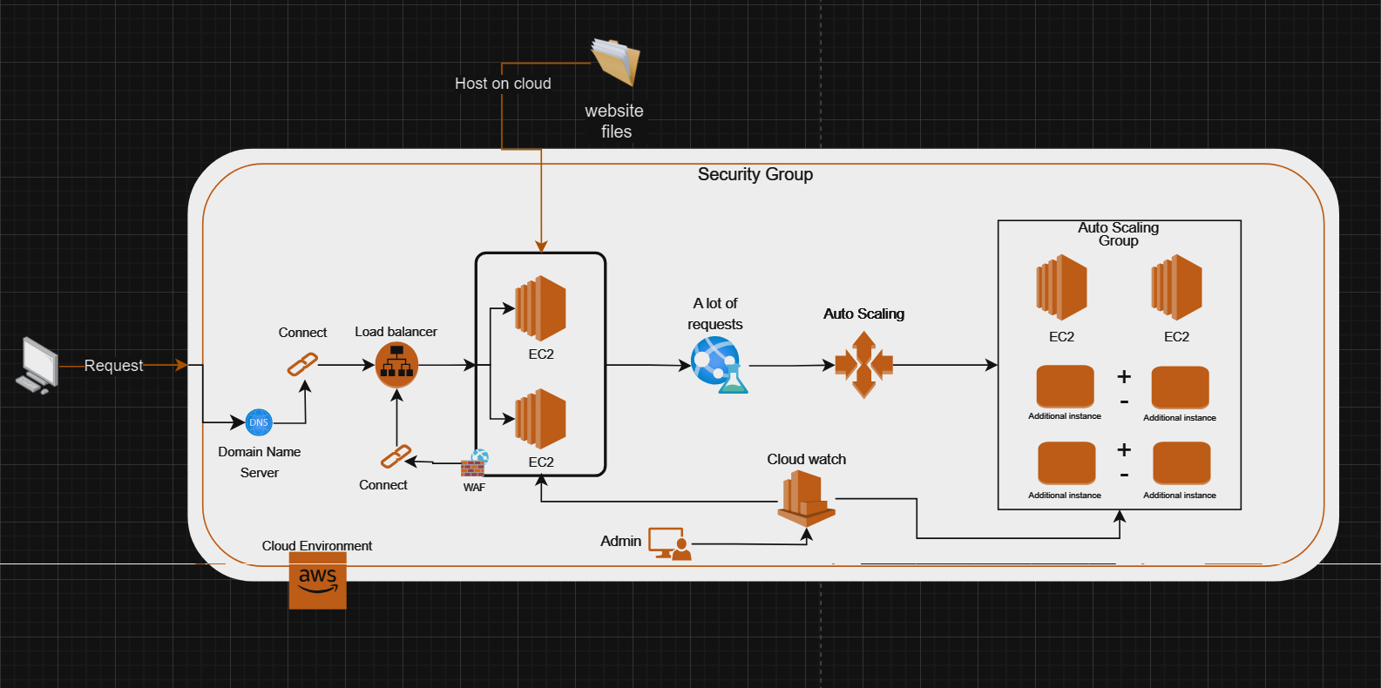

**User Request to Domain Name System (DNS)**

The user's journey to the website begins with a request sent from their devices. This request queries the DNS system, which works like an Internet address book, translating a website's domain name into a machine-readable IP address. The DNS server steers the request in the right direction, towards the cloud services where the website is located.

**Load Balancer**

Once the IP address is resolved, the request arrives at the load balancer, which plays a crucial role in managing incoming traffic. The load balancer efficiently distributes web traffic across multiple servers to prevent overloading on any single server, thus ensuring optimal performance and reducing downtime risk.

**Web Application Firewall (WAF)**

Before traffic is routed to servers, it passes through the Web Application Firewall (WAF). This firewall scans incoming requests to filter out any malicious traffic, such as hacking attempts or denial of service attacks, and protects the web application from a range of web-based threats.

**EC2 Instances**

The heart of cloud hosting setup is EC2 (Elastic Compute Cloud) instances. These are virtual servers in AWS where website files and applications are hosted. They handle web application processing and execution, and deliver the content back to the user who made the request.

**Security Group**

EC2 instances are surrounded by a security group that acts as a firewall for servers in the cloud. It lays down the rules for incoming and outgoing traffic, ensuring that only legitimate and secure traffic can access the web application.

**High Traffic Management**

In scenarios where there is a significant spike in web traffic (a lot of requests), the infrastructure must be prepared to handle the increase without compromising performance. This is where autometry comes into play.

**Auto-scaling Group**

Autoscale is a mechanism that automatically adjusts the number of active EC2 instances up or down based on the current load. If there is an increase in traffic, new load sharing instances will run. If traffic declines, additional instances are removed to optimize costs.

**CloudWatch Monitoring**

Monitoring cloud health and performance is where AWS CloudWatch comes in. It tracks various metrics and logs from EC2 instances and other AWS resources, allowing real-time monitoring. This service allows the administrator to be alerted to problems, ensuring that they can act quickly to maintain the smooth operation of the site.

**Administration**

Behind the scenes, the administrator (admin) oversees the entire process. They have secure access to manage the cloud environment, monitor resource usage, deploy updates, and modify configurations to ensure that the cloud-hosted website remains secure, functional, and ready to serve users.

This architecture demonstrates a comprehensive approach to cloud hosting, providing a combination of performance, scalability, and security. Each component of DNS The administrator has a specific role, ensuring that the website is able to handle traffic safely and efficiently, providing a reliable online experience for its users.

**7TASK: B.**

As a cloud engineer tasked with the pivotal role of designing a secure, scalable, and efficient cloud environment for Global Electronic Services Corporation (GESC), my approach is deeply rooted in understanding the unique requirements of providing educational services on a global scale. My design reflects a combination of advanced technology and strategic insight, with a focus on providing seamless access to digital resources for a diverse student body while maintaining stringent security and operational standards. The architecture is meticulously designed to ensure that each student's interaction is met with unwavering reliability, fast response, and complete data protection, embodying GESC's commitment to excellence in education.

The basis of the design is based on the principles of scalability and high availability, ensuring that resources are not only sufficient but also used efficiently. This is achieved through strategic options such as using flexible computing power and implementing automatic scaling, allowing the infrastructure to safely handle volatile applications – vital for periods of high enrollment rates or during exam seasons.

Recognising that GESC services must be accessed anytime, from anywhere, without interruption, the deployment of flexible load balancers ensures smooth traffic distribution to maintain high performance. This is coupled with the adoption of advanced monitoring through tools such as AWS CloudWatch, giving GESC the flexibility to proactively address issues and maintain the highest level of operational excellence.

In terms of security, which is critical to protecting sensitive educational data, every layer of infrastructure is fortified. From strong firewalls and encryption protocols to tight identity management and access practices, the goal is to create a bulwark against evolving cybersecurity threats. Particular attention is paid to data protection and privacy, and compliance with international standards and regulations, which is critical for an organization like GESC operating on the world stage.

Every component is meticulously selected and configured, from data storage solutions to network configurations, to ensure cost-effectiveness without compromising quality of service. My approach involves continuous improvement and reassessment of the security landscape, ensuring that GESC's cloud remains at the forefront of technological advances while strengthening the ecosystem where students and teachers can thrive safely and efficiently.

At its core, the cloud solution I propose to GESC not only meets the immediate needs of a large and dynamic education provider, but is also designed to adapt to its future growth and evolving challenges, ensuring it remains a leader in providing digital education services.

**Scalability and flexible infrastructure**

**Amazon EC2 servers and autoscale:**

GESC operations require a highly scalable cloud infrastructure to effectively serve the global student community. Amazon EC2 server support, along with Auto Scaling, directly meets this need. These servers provide the necessary computational power, while Auto Scaling allows the system to expand or decrease the number of active servers in real time, based on actual demand. This ensures that during periods of high utilization, perhaps during university exam seasons, the system remains responsive and reliable without incurring unnecessary costs during quieter periods. It's a key feature that underpins GESC's commitment to providing uninterrupted access to online courses and resources.

**High availability and real-time access**

**Flexible Load Balancing (ELB):**

For GESC, which provides time-sensitive learning resources, continuous uptime and quick access are non-negotiable. Integrating flexible load balancing improves the distribution of inbound network traffic across multiple EC2 instances. This not only prevents overloading and potential service outages, but also ensures that students from any region can access e-books and courses without delay, reflecting GESC's dedication to high service standards.

**Cost-effective resource management**

**Strategic use of automatic measurement:**

Financial efficiency is critical for GESC to maintain its service offerings. Auto Scaling stands out as an important feature, as it dynamically aligns resource allocation with usage patterns. During peak times, such as the beginning of the semester, when students are actively looking for subjects, the infrastructure adapts by adding more strength. Conversely, it is scaled down during off-peak periods to reduce unnecessary expenses, supporting GESC's strategic approach to financial supervision.

**Enhanced security measures**

**Web Application Firewall (WAF):**

Due to the sensitive nature of student data and educational content, GESC's cloud solution includes a robust security framework. WAF plays an essential role in defending the platform from various web-based threats, ensuring that student information is kept safe. By scanning incoming traffic for potential vulnerabilities and threats, WAF upholds GESC's robust security principles, and maintains the integrity and confidentiality of its services.

**Systematic handling of traffic**

**Strong network configurations:**

The network architecture is designed to handle the vast and diverse web traffic that a large organization such as GESC may encounter. Security group settings ensure that only authorized traffic can access the service, protecting the system from potential breaches and unauthorized access. This thoughtful configuration highlights GESC's priority of securing the educational ecosystem for all users.

**Proactive monitoring and incident management**

**Real-time insights with Amazon CloudWatch:**

For a company like GESC, insight into system performance is critical. CloudWatch provides detailed monitoring and logging that enables the management team to detect and respond to issues instantly. Whether it's a performance throttle or a security incident, CloudWatch ensures that GESC can maintain a high level of service quality and security, in line with its commitment to providing reliable educational services.

**Every aspect of GESC's cloud infrastructure is selected and designed to meet its specific organizational needs, from the flexible nature of cloud resources to the exact level of security. These elements come together to form a cohesive, scalable, and secure cloud environment that not only supports GESC's operational goals, but also aligns with their strategic vision to provide accessible and reliable educational services to students worldwide. Through continuous monitoring, strategic expansion, and vigilant security practices, GESC can confidently overcome the complexities of delivering digital education services on a global scale.**

**8,9TASK: B.**

|  |  |
| --- | --- |
|  | First, I created EC2 versions and uploaded my website files to them, called "Hosting". To enhance security, I've tweaked my access requirements, starting with a crucial step: I've blocked requests from everywhere except a specific IP address that I creatively manage.  Now, let's dive deeper into ensuring maximum availability. By distributing each instance of my site across different subnets, I effectively enhanced its accessibility. This means that any obstructions in one part of the network will not bring down the entire view. Each case operates within its own small bubble, protecting it from potential problems elsewhere.  This strategic step is not only about technological intelligence, but also about providing high-level service to users. It ensures a seamless and reliable experience, which ultimately benefits both the service and the business behind it. |
|  | After that, I created a load balancer to distribute requests between instances and linked this distributor to a target group containing healthy instances, which is the first solution to enhance flexibility to maintain the continuity of server service, so that it does not crash.  See the link to see the name of the load distributor  (load balancer) |
|  | I used access control lists (ACLs) and web application firewalls (WAFs) because they provide a strong layer of security for both my network and web applications. ACLs help me manage who can access different parts of my system, acting like digital gatekeepers who only guarantee authorized users and traffic access to certain areas of my network. This is critical to controlling access to sensitive data and system resources. On the other hand, I deployed WAF to protect my web applications from common internet threats such as SQL injection, cross-site scripting, and other exploits. WAF acts as a vigilant security guard, scanning all incoming web traffic to prevent malicious activities before they cause damage. Together, ACL and WAF lists provide a comprehensive security setup that protects my digital environment from unauthorized access and cyberattacks, ensuring my operations run smoothly and securely. |
|  | I implemented automatic adaptation because it's like having a smart thermostat for my cloud resources – it automatically adjusts everything to maintain optimal performance and efficiency. When demand for my apps grows, the auto-expand feature seamlessly increases resources to handle the increase, ensuring users have seamless, uninterrupted access. Conversely, during periods of calm, resources are reduced, helping to reduce unnecessary costs. |

**TASK: B.10**

To ensure that GESC provides a secure and reliable eBook search platform for students around the world, you set up a robust cloud infrastructure with Amazon Web Services (AWS). Here's a detailed breakdown of what you've implemented, why, and how it all works together to achieve our security and operational goals:

**1. Instance AWS:** I started setting up Instance 2from AWS. This dual-instance setup is essential for redundancy and reliability. If one Instance encounters issues or crashes, the other can take over the task, ensuring that our eBook search service remains available without interruption. This redundancy is key to achieving high availability and fault tolerance.

**2. Upload and encode the HTML file:** You uploaded a base HTML file to this instance to reflect the original system website. To enhance security, especially to protect the integrity of data and the confidentiality of the content we provide to students, Amazon S3 has also been used for storage. S3 is not only a powerful data storage system, but it also offers encryption capabilities. I have enabled the default encryption feature in S3 to encrypt our data while we are inactive. This means that our files are automatically encrypted before being stored, and decrypted when accessed, without any extra effort on our part. This step is vital to protect against unauthorized access to data and ensure compliance with data protection regulations.

**3. Access Control Lists (ACLs) and Web Application Firewall (WAFs):** To further secure our infrastructure, I implemented ACLs and WAFs. ACLs help control who can access our AWS resources and how to interact with them, based on predefined security rules. I can determine which IP addresses are allowed to access our instances, thereby preventing potential attackers from accessing our website. WAF, on the other hand, provides another layer of protection by scanning incoming traffic to our web applications. It helps protect against common web exploits such as SQL injection, which represent pervasive threats to web platforms.

**4. Auto Scaling:** To meet the challenge of scalability and efficiently manage volatile requirements, you set up autoscale on AWS. This feature dynamically adjusts the number of active instances according to the load. When demand increases, autoscale automatically starts more instances to handle the load, ensuring our service remains smooth and responsive. Conversely, during periods of low demand, the company cuts resources to reduce costs without sacrificing performance. This capability not only ensures optimal use of resources, but also supports our goal of providing uninterrupted and real-time eBook search.

**5. Auto Scaling Settings:**

**1. Group size - required capacity: 2**

Starting with the required capacity for two instances ensures that at least one backup instance is always running. This redundancy is critical for high availability and fault tolerance. This means that if one instance fails, the other instance can seamlessly take over the task without disrupting the user experience on the eBook search platform.

**2. Scaling Limits – Minimum capacity required: 2**

Setting the minimum required capacity to 2 is in line with our goal of redundancy. This setting ensures that the autoscale set never falls below two instances, thus maintaining our baseline repeatability at all times.

**3. Scaling Limits- Maximum capacity required: 6**

The maximum capacity is set to 6 to allow for a significant expansion in response to rising demand. This cap ensures that during periods of high traffic, such as exam seasons or when new courses are released, the system can efficiently scale up to handle increased loads. Once demand drops, the system can downsize again, ensuring cost efficiency.

**4. Auto Measurement – Target Tracking Measurement Policy**

**Metric Type:** Average Network In (bytes)

**Target Value:** 100

**Instance Warmup:** 10 ثوانٍ.

The target tracking measurement policy automatically adjusts the number of instances to keep the average network input (the amount of incoming network traffic) close to the target value. By selecting "grid average" as the metric, the automatic metering system dynamically scales based on actual usage, which is a direct indicator of user demand. The target value is set based on typical traffic baseline measurements, which is 100 bytes, depending on what is normal for the system. A lower goal may mean scaling frequently, ensuring performance isn't compromised by sudden increases in user demands.

**By integrating these elements with redundant AWS Instances, encrypted storage on S3, strict access controls via ACLs, robust traffic filtering with WAF, and responsive scaling through autoscale — you've designed a secure, efficient, and scalable cloud infrastructure that complies with GESC operational requirements and security authorizations. Taken together, these actions ensure that we provide a reliable, secure, and user-friendly experience for students who access our eBook Search Platform.**

* As a cloud engineer, I recommend using the SQL rule "AWS-AWSManagedRulesSQLiRuleSet" in setting up our web application firewall because it acts as a vigilant security guard against SQL injection attacks. These attacks can infiltrate malicious commands into our databases, which may expose sensitive student information or disrupt our service. That's why I think this rule is necessary:

**Why SQL rule is important:**

**1. Active Protection:** This rule continuously scans incoming web traffic, looking for any signs of SQL entry – a technique used by attackers to manipulate databases. When it detects something suspicious, it intervenes to block that traffic, effectively stopping potential threats before you can do any damage.

**2. Stay informed:** This rule, managed by AWS, is not static. It evolves, receiving updates as threats and new technologies identifies. This keeps our defenses strong against the latest SQL injection strategies without having to manually adjust or constantly adjust our settings.

**3. Simplicity in security:** By leveraging this AWS-managed base, we reduce the complexity of our security operations. It's like having an AWS team of experts continuously improve our defenses, allowing us to focus more on improving other areas of our platform.

**4. Efficiency and effectiveness:** This base is designed to protect without causing delays or slowdowns, ensuring that our application remains fast and responsive. It offers robust security without compromising the performance our users expect.

**Why it is so important:**

**Protecting our users:** Our students rely on us to access essential educational resources. Keeping their data safe from SQL injection not only protects them, but also maintains the trust they place in our platform.

**Legal and compliance:** Compliance with data protection laws is not just about compliance; it is about liability. By implementing this rule, we help ensure that our operations are in line with these regulations, and avoid potential legal issues.

**Reliable Service:** By protecting our databases from unwanted intrusions, we ensure that our e-book search service runs smoothly around the clock. This reliability is key to providing a consistent and reliable user experience.

**Implementation Strategy:**

Although AWS manages the rule, it's important for us to monitor how it performs. Checking security logs regularly helps us improve our defenses and ensures legitimate traffic flows smoothly.

This base represents a strong layer of protection, but works best in conjunction with other security practices such as secure encryption, regular security audits, and strict access controls within our databases.

The adoption of AWS-AWSManagedRulesSQLiRuleSet is a strategic step toward immunizing our application against SQL injection , while underscoring our commitment to protecting our educational platform and supporting the integration of our services. It's like making sure our doors have the best locks at work, and keeping an eye on anyone trying to open them.

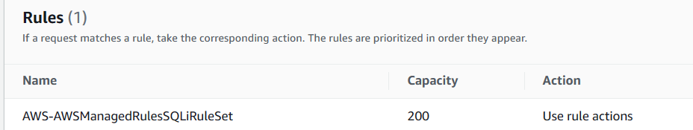

|  |  |
| --- | --- |
|  | The first image shows a login form where the user enters the username and password. The Username field displays an entry "' or ''='", which is a typical payload for SQL entry. This entry tries to process a basic SQL query that verifies the logon credentials. The goal is to change the query logic to something that always returns true, thus bypassing authentication checks without the need for a valid SQL username and password. |

Second recommendation ej Modify the rules received to include PostgreSQL access specifically limited to my personal IP address. This is a smart security practice that helps keep our database secure while allowing me the necessary access for management and maintenance tasks:

**1. Focused access control:**

Limiting PostgreSQL traffic to just my IP address means that I'm the only one who can access the database directly. It's like having an exclusive passcode that only I know, which greatly reduces the risk of unauthorized access.

**2. Minimize security risks:**

By narrowing access to a single IP address, the likelihood of attacks is significantly reduced. It's like reducing the number of doors in a building, fewer doors means fewer chances of breaking into someone.

**3. Compliance and Monitoring:**

This setting not only complies with data security best practices, but also simplifies compliance with privacy and security regulations. It makes it easy to audit and verify who accessed the database and when, ensuring that all accesses are legitimate and authorized.

**4. Balance between security and accessibility:**

While securing access to the database, this database also ensures that critical updates, backups, and management tasks can be performed without hindrance. It's about keeping the database safe and efficient, ensuring that I can do my job effectively without compromising security.

**Practical considerations:**

**Dynamic IP addresses:**

If my IP address changes frequently (which can happen with some ISPs), I'll need to update my security settings accordingly to maintain accessibility. This is an important factor to consider to avoid blocking your access to the database.

**Security Strategy Classes:**

Besides IP restriction, I also make sure that our data transfers are encrypted and that strong authentication procedures are in place. Think of it not only with a closed door but also with surveillance cameras and a security alarm.

**Ongoing security reviews:**

Regularly checking and updating security rules ensures they continue to effectively protect our resources as threats evolve and our operational needs change.

By implementing this rule, I ensure that our database environment is protected from large-scale threats while still being accessible to carry out the necessary administrative tasks. It is a strategic procedure that maintains a high level of security without sacrificing the operational efficiency required in a dynamic educational services environment like ours.

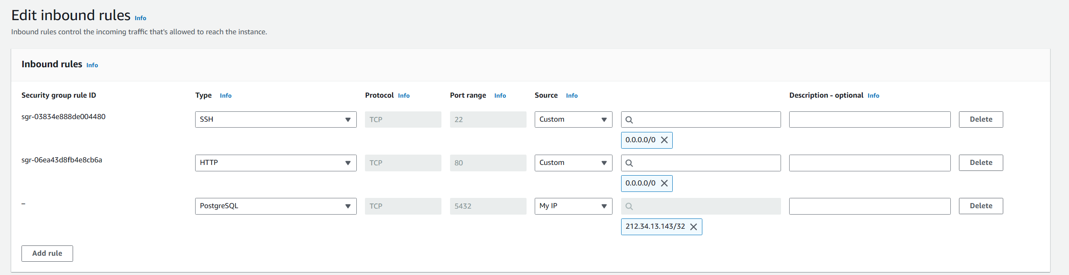

**TASK: B.11**

As we progress through GESC's transition to a secure cloud-based eBook search services infrastructure, it is essential to regularly evaluate our security setup against the initial strategy and evolving best practices. This systematic review helps identify areas for improvement and ensures that our defenses are strong against new threats. Below is a detailed assessment, combining our existing apps with native plans, followed by recommendations to enhance our cloud security.

**Our original cloud security strategy aims to protect the integrity, confidentiality, and availability of GESC data while transitioning to cloud services. The plan focused on implementing strong access controls, protecting against web threats, and ensuring our infrastructure could be securely expanded. This analysis compares our current applications with those initial goals, identifies any differences, and identifies strategic improvements.**

**Current setup vs. original plan**

**Access Control Access:**

**Original plan:** Our strategy was to use access control lists (ACLs) and security groups to strictly manage access to cloud resources, ensuring that only authorized employees have access to sensitive data.

**Current implementation:** We have created ACLs and security groups that restrict access based on IP addresses and specific user roles.

**Review:** This preparation mostly corresponds to our initial goals. However, the changing nature of roles and potential changing IP addresses requires more frequent updates and revisions to these controls to prevent unauthorized access.

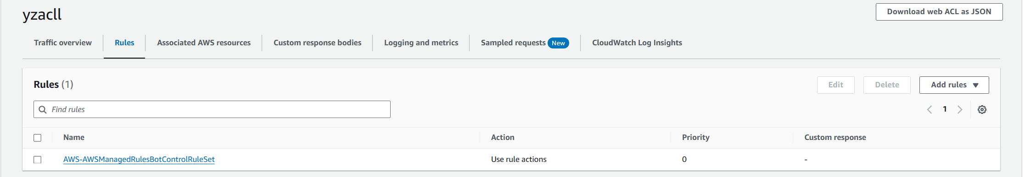

**Threat Protection:**

**Original plan:** We intended to deploy web application firewalls (WAFs) to defend against common web threats such as SQL and XSS injections.

**Current implementation:** WAF is developed with AWS-managed rules, to target standard web vulnerabilities.

**Analysis:** WAF successfully prevented public threats. However, we lack custom rules that address the specific vulnerabilities unique to our applications, which may make us vulnerable to specialized attacks.

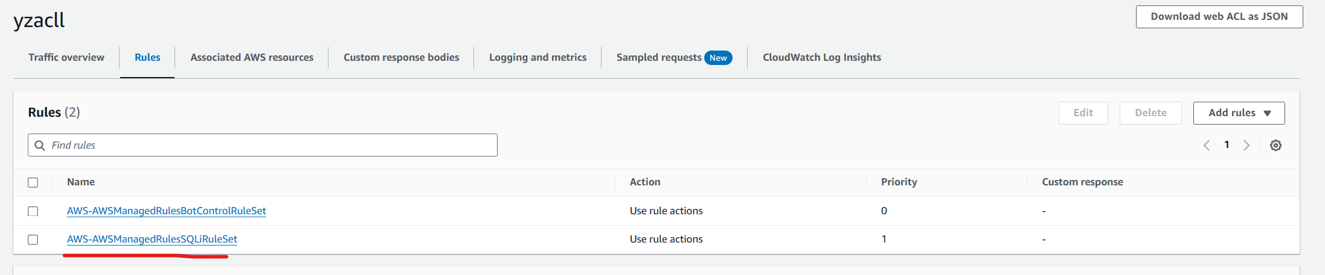

**Scalability and flexibility:**

**Original plan:** Automatic expansion was chosen to ensure that our infrastructure can handle various loads without compromising security.

**Current implementation:** Autoscale is configured and activated, with parameters set based on network input and CPU usage.

**Analysis:** While autoscale has efficiently kept pace with rising demand, the integration of security monitoring with scalings needs to be strengthened. This is intended to ensure that security measures are applied consistently in all new cases, while maintaining uniform protection.

**Recommendations for improvement**

**Enhanced access control:**

**Recommendation:** Adopt more dynamic and adaptable access control procedures using advanced tools such as AWS IAM to manage permissions more accurately.

**Benefits:** This approach allows real-time adjustments to access permissions, reflecting changes in user roles or network configurations, thereby maintaining tight security.

**Advanced threat protection:**

**Recommendation:** Strengthen WAF by incorporating additional application-specific rules and participating in routine penetration testing to detect and correct unique vulnerabilities.

**Benefits:** Customizing security measures to directly address the specific risks our applications face significantly reduces the chance of targeted breaches.

**Improve scalability and security integration:**

**Recommendation:** Ensure that autoscale settings are tightly integrated with our security policies so that new instances automatically adopt all existing security configurations.

**Benefits:** This practice ensures that every part of our infrastructure remains secure, even during unplanned expansions, thus avoiding potential security vulnerabilities.

**Continuous monitoring and auditing:**

**Recommendation:** Improve the monitoring and audit framework with tools such as AWS CloudTrail and AWS Config to ensure all actions are tracked and anomalies are quickly addressed.

**Benefits:** This enhances our ability to quickly detect and respond to threats, significantly improving our overall security posture.

**Load dimensions and flexibility with DDoS protection:**

**Recommendation:** Integrate AWS Shield DDoS protection with our application load balancers (ALBs) to enhance real-time threat detection and response capabilities. AWS Shield provides advanced, lightweight detection mechanisms that are essential to effectively identify and mitigate distributed denial of service (DDoS) attacks.

**Benefits:** By connecting AWS Shield with ALBs, we ensure that our infrastructure is not only protected against a wide range of DDoS attacks, but also benefits from the adaptive capabilities of AWS Shield. This setting helps maintain uninterrupted service availability, protecting our network from large-scale, sophisticated application-level attacks. Adaptive learning technology within AWS Shield allows our defenses to evolve in response to new and emerging DDoS tactics , ensuring our system remains robust against complex threats. This proactive defense strategy significantly enhances the flexibility and reliability of our cloud architecture, ensuring secure and continuous operation for all users.

By addressing these recommendations, we are not only aligning our cloud security practices with our initial ambitions but also creating a stronger and more resilient infrastructure. This proactive security management will protect GESC's critical data and services from current and future threats while supporting our goals of scalability and operational efficiency. Regular reviews and updates will be crucial in keeping our cloud environment secure and robust.

**TASK: C**

**Create a secure cloud and configure security**

**TASK: C. 12.13**

As we move forward to enhance the security and resilience of our cloud-based systems at Global Electronic Services Corporation, thorough testing of our deployed security measures is essential. This testing phase is an integral part of our strategy, ensuring that all aspects of our infrastructure not only function as intended but are also able to deal with real-world threats and load scenarios. The purpose of this detailed test plan is to rigorously evaluate the effectiveness of our security configurations, ranging from robustness against automated threats and SQL injection attacks to the ability to adapt to our autoscale capabilities and SSH access security. By carefully assessing these areas, we aim to identify any weaknesses and strengthen our defenses, thus ensuring the reliability and security of our services for all users. This plan outlines a series of structured tests, each designed to challenge the different components of our system and ensure that they meet our stringent security standards.

**Let's start with the tests:**

**1. Bot control performance test with JMeter**

**Test case:** Bot control under pressure

**Objective:** To assess how well the bot control is managed under great pressure.

**Tools:** JMeter for traffic simulation, firewall for web applications.

**Procedure:**

Use JMeter to simulate high traffic destined for the control bot.

Measure the bot's response to multiple and simultaneous commands.

Evaluate how the bot handles requests, specifically looking for HTTP 405 responses (the method is not allowed).

**Expected results:**

The bot loads successfully and remains responsive under pressure.

The system handles unauthorized bot requests correctly, and responds using HTTP 405.

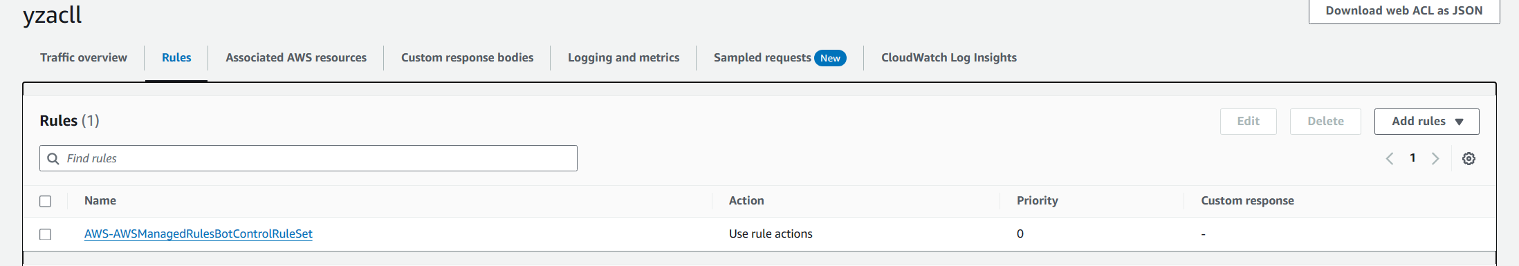

I noticed a significant increase in automated traffic, including bots that were draining resources and posing security risks, such as potential data theft and fraudulent requests. It became clear that distinguishing between human users and real-time robots was critical to maintaining the integrity and accessibility of my services.

To address this issue, you decide to implement a CAPTCHA botnet control rule in the AWS Web Application (WAF) firewall. CAPTCHA helps verify that a user is human before allowing access to certain online services, thus preventing bots from accessing the system while ensuring that legitimate users can be followed with minimal disruption.

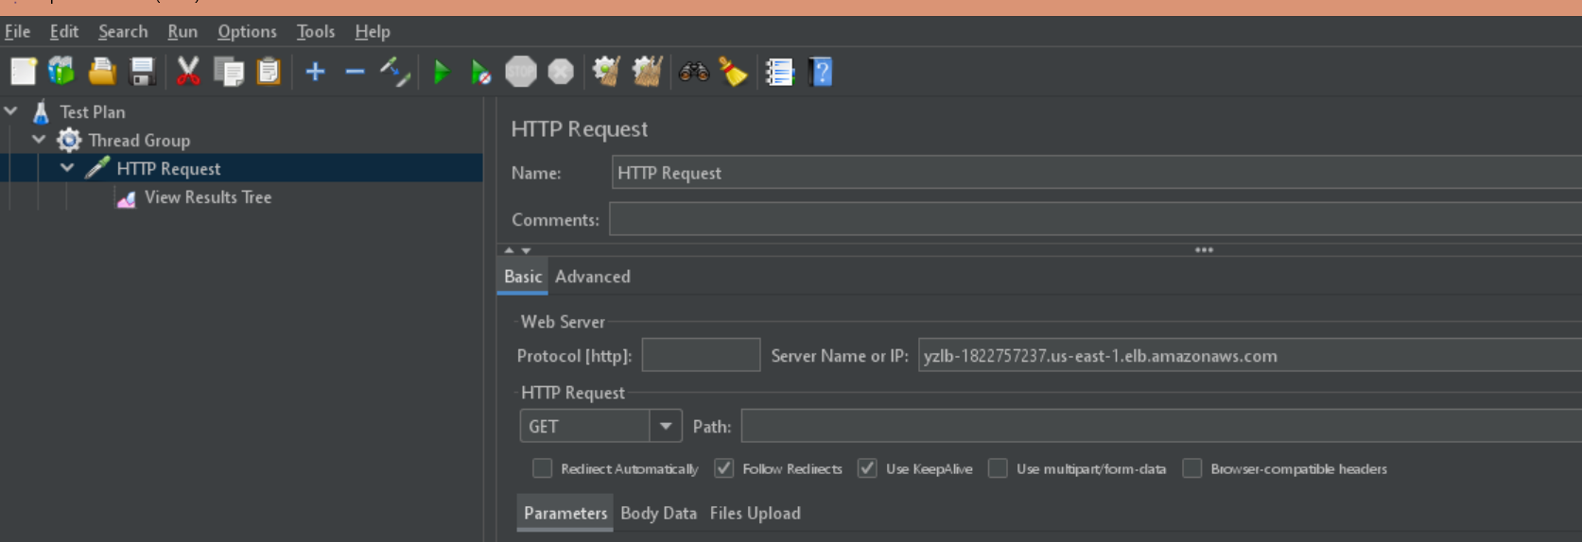

With the rule applied, JMeter was used to simulate human and robotic traffic. This test was crucial to ensure that the new security measure effectively prevents automatic access attempts while allowing real users to proceed after completing the CAPTCHA test. My goal was to enhance security without negatively impacting the user experience.

The results were very reassuring. The CAPTCHA test successfully thwarted bots that failed to pass the challenge, significantly reducing malicious traffic. Human users were able to access my services seamlessly after solving the CAPTCHA test, confirming the effectiveness of this approach in distinguishing between legitimate and automated traffic.

**2. Auto scaling capability test with JMeter**

**Test Case Name:** Auto scaling **Proficiency Assessment**

Objective**:** Verify the responsiveness of  **the Auto scaling**  system to different load levels.

**Tools:** JMeter for pregnancy test.

**Procedure**:

Use JMeter to create different loads on the system.

Monitor how the system scales up or down in response to these changes.

Test the load balancing function to ensure even distribution of traffic.

**Expected results:**

The system must dynamically adjust its capacity based on the load, demonstrating **an effective** Auto scaling.

Load balancing must be efficient, with no one node overshadowing the other.

Initially, I reviewed the AWS Management Console to confirm basic setup before starting stress testing. At this point, there were 2 instances running, named "Firstweb" and "Secondweb", the goal of this setup was to provide initial load balancing and redundancy.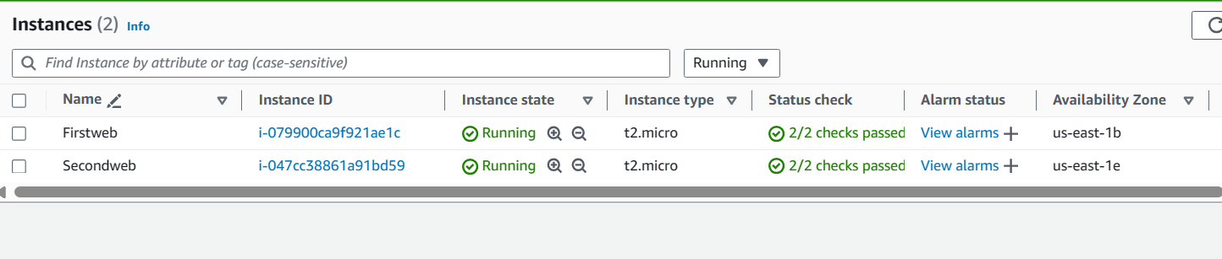

Using JMeter, I executed a series of HTTP requests designed to simulate increased traffic and load on our web services. The goal was to run autoscale actions based on predefined limits in our AWS environment , thereby testing the system's response to simulated traffic spikes.A screenshot of a computer

Shortly after testing began, some HTTP requests were initially rejected , indicating that the Web Application Firewall (WAF) was filtering and blocking what it considered potential threats or abnormal activities. This response demonstrated the effectiveness of our security measures in detecting and preventing threats in real time.

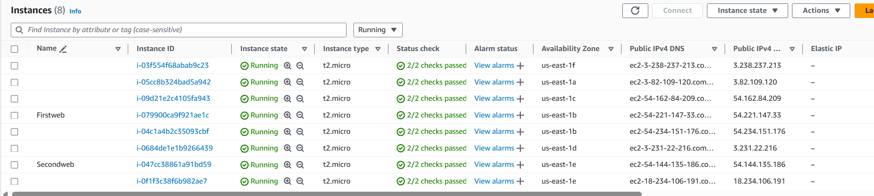

Soon after, about five minutes, I returned to the AWS Management Console to assess the autometric response. According to forecasts, the number of instances increased from 2 to several other instances. This increase was a direct result of the autometric feature that works as intended to efficiently manage the increased load.

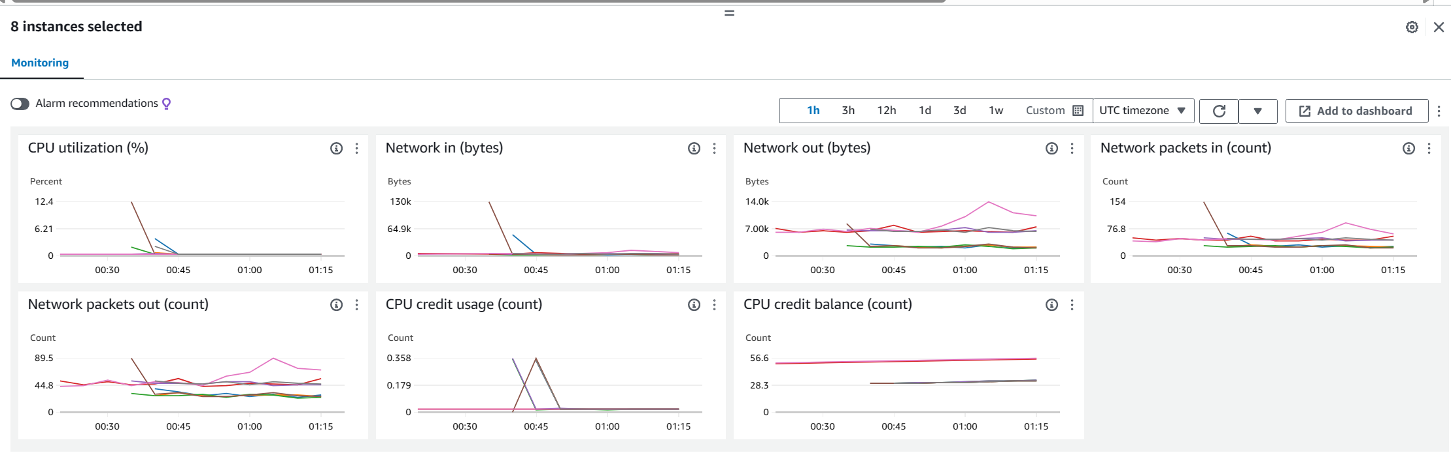

The metrics displayed on the dashboard show the system's response to a stress test performed using JMeter, especially in the context of auto-scaling. During the test, we can observe significant fluctuations in CPU utilization, network traffic, and CPU credit usage. These changes indicate how the system dynamically adjusts its resources to cope with the increased load. Initially, we see a jump in CPU usage and network activity when the auto-scaling feature started working to meet the simulated demand. This is followed by stabilization in resource use, which indicates that additional copies are likely to be released to distribute the load more evenly. The decrease in post-peak CPU usage indicates that the system has succeeded in increasing resources to meet demand and then decreasing them when the load decreased, maintaining an effective balance between performance and resource utilization. This behavior demonstrates the effectiveness of the auto-expansion setting in adapting to changing traffic conditions, ensuring system stability and responsiveness even under pressure.

**3. SQL injection defense test with JMeter**

**Test case name:** SQL injection vulnerability scan

**Objective:** To assess the strength of SQL injection defenses.

**Tools:** JMeter for stress testing, SQL injection protection system.

**Procedure:**

Simulation of SQL injection attack using JMeter.

Monitor and record how the system detects and blocks these attempts.

Check the integrity of the database after an attack.

**Expected results:**

All SQL injection attempts must be blocked.

The system must remain secure, with no data integrity issues

Initially, we encountered potential vulnerabilities in our web application that could be exploited via SQL injection. This type of attack manipulates backend databases by inserting malicious SQL statements into input fields for execution (for example, login forms). Our goal was to protect sensitive database interactions, especially those involving user input that attackers could.

To mitigate these risks, I implemented AWS-AWSManagedRulesSQLiRuleSet under the AWS Web Application Firewall (WAF). This set of rules is designed to detect and block common SQL injection patterns and tactics. By integrating this set of rules, we leveraged AWS's ever-updated algorithms, which rely on existing threat intelligence and known SQL injection technologies , thereby strengthening our application's defenses. Tampering with it.A screenshot of a computer

After posting the rules of injection SQL, we conducted tests to evaluate the effectiveness of the composition WAF. The test involved trying to enter commands SQL through the input fields to see if WAF It will prevent these attempts appropriately and record accidents. Testing was crucial to ensure that the rule set was active and properly configured to provide the required protection.A screen shot of a computer

The result of this implementation was immediately noticeable. When trying to simulate a SQL injection attack, instead of executing the malicious query, the system returned the error "403 Blocked". This response indicates that access to the database is denied to the request, confirming that the SQL entry attempt has been successfully recognized and blocked by WAF. In addition, no unauthorized data has been leaked or changed, thus maintaining the integrity and confidentiality of our database.

**4. Network port security audit using Nmap**

**Test case name:** Find exposed network vulnerabilities

**Objective:** to ensure that no unnecessary ports are opened, thus enhancing the security of our network.

**Tools:** Nmap to clear ports.

**Procedure:**

Use Nmap to scan our network for any open ports that should be closed to prevent unauthorized access.

Analyze the results to determine which ports are unexpectedly open.

Review security configurations and update firewall rules to close any open ports that are not required for our operations.

**Expected results:**

The inspection should only reveal those outlets necessary for business operations; any other open ports should be marked for closure.

After adjusting the firewall settings, the subsequent scan should confirm that all non-primary ports have been successfully closed.

The system maintains a secure position while closing all unnecessary ports, ensuring enhanced network security.

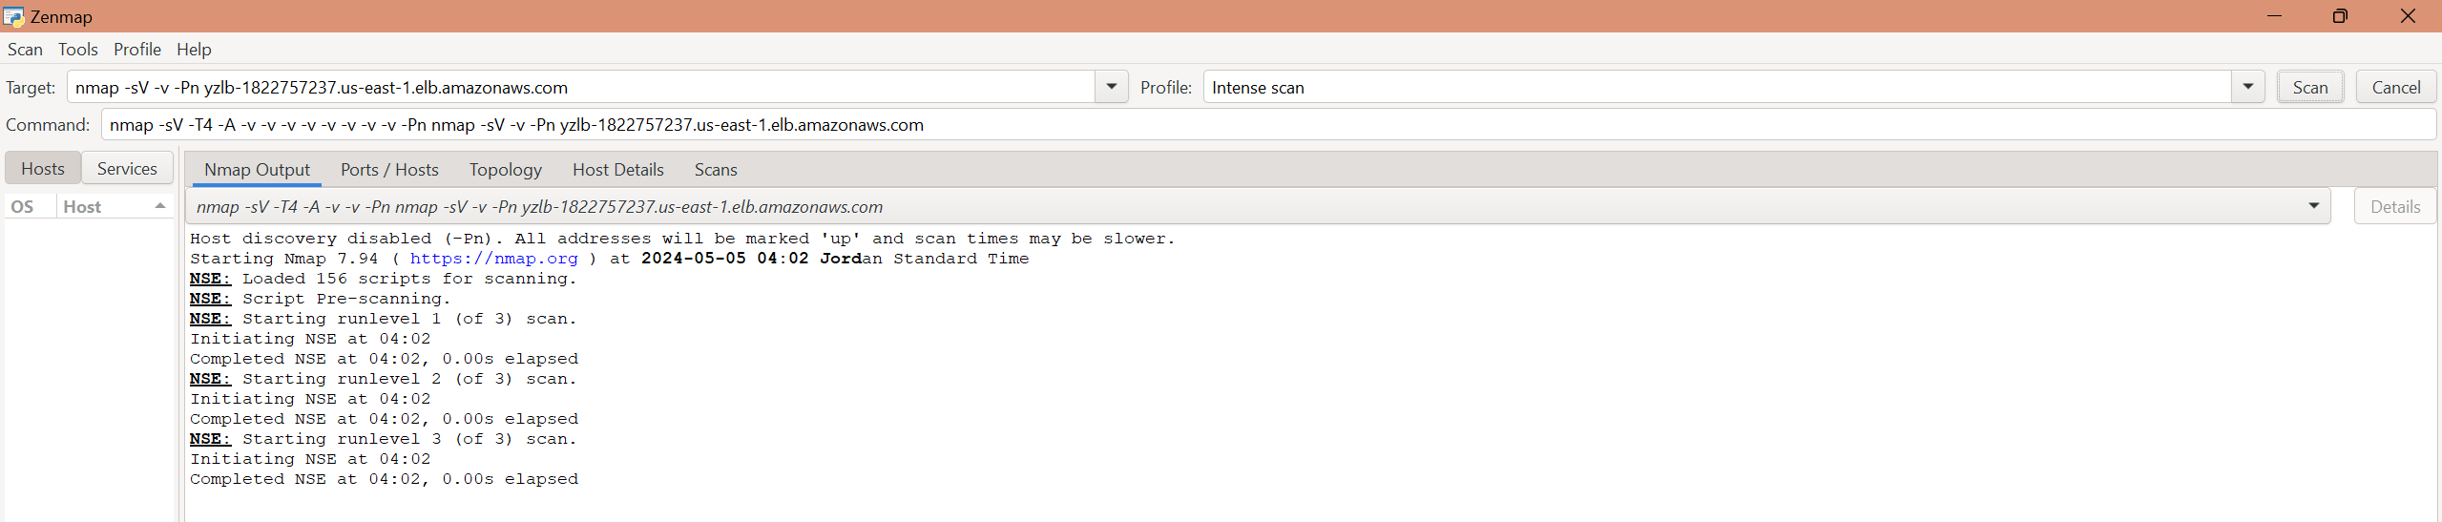We start with the process of searching for open ports

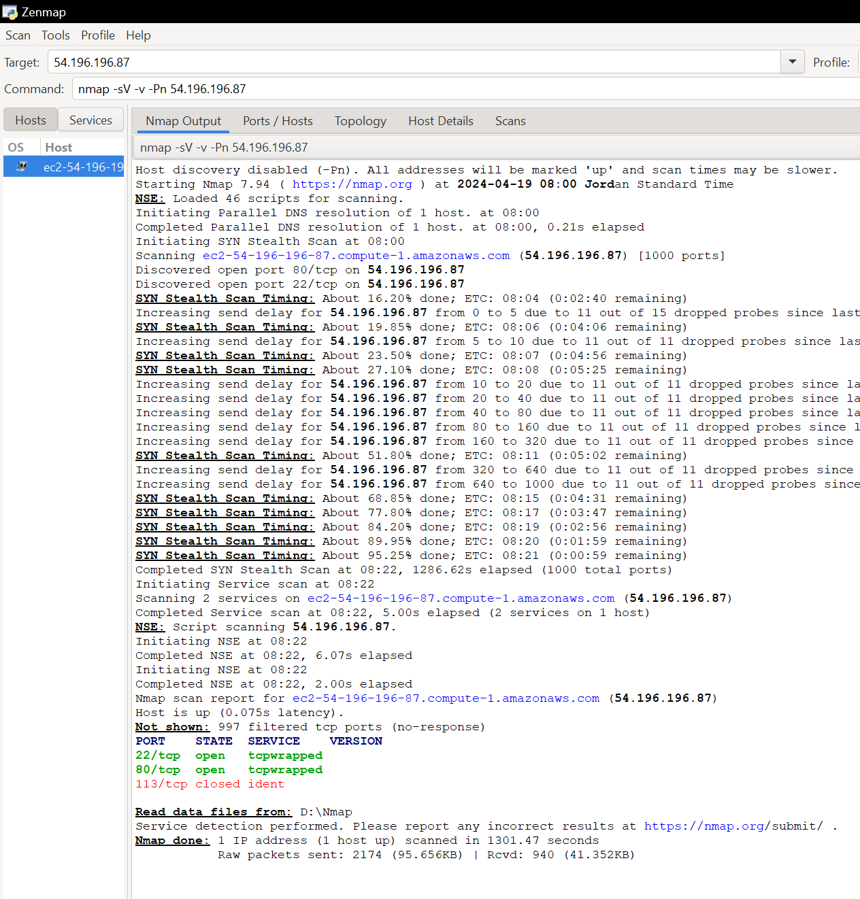

After reviewing the security protocols and checking the network ports using Nmap, I noticed that SSH port (22) was initially open, posing a potential security risk. Recognizing the need to tighten the security of our system, I decided to adjust the settings in our AWS security suite

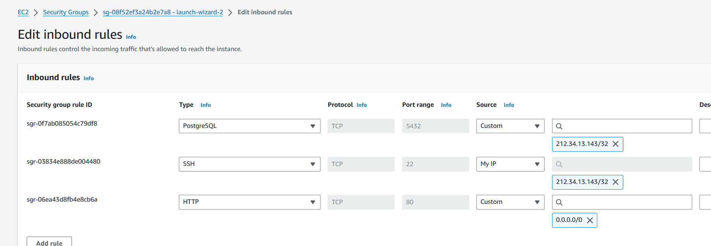

I specifically modified the incoming rules to close port 22, effectively blocking external SSH access to our systems. This decision was motivated by the need to prevent unauthorized access and mitigate the risk of potential violations.

The result of this action is evident in the latest NMAP scan results, where port 22 now appears as "Closed". This change reinforces our security posture by ensuring that any attempt to access our servers via SSH must go through stricter access protocols, which include VPN and internal network access, thereby reducing the surface area for potential cyberattacks. It is a necessary step towards ensuring that our infrastructure remains secure and resilient against unauthorized access attempts.

**Task: C.14**

**Test and analysis results**

**Test the performance of robot control with JMeter:**

**The result: The** controller performed great under high traffic conditions and multiple concurrent requests, successfully handling all requests with appropriate responses, particularly HTTP 405 replay for unauthorized requests.

**Strengths:** The robot has shown excellent flexibility, effectively managing large loads without getting stuck. Its ability to respond properly to unauthorized actions shows that security protocols are robust and reliable.

**Weaknesses:** While the robot handled test conditions well, the potential for latency issues or crashes under more severe conditions was not fully tested. This leaves a gap in our understanding of the limits of robot performance.

**Recommendations:** It is necessary to push the system beyond current test conditions to fully understand its capabilities and limitations. Further stress testing under extreme scenarios will help identify any latency issues or failure points. The application of rate reduction and more advanced robot management solutions can prevent system overload and enhance overall stability.

**Evaluation of Auto Scaling efficiency using JMeter:**

**The result: The** autoscale system was responsive and efficient, seamlessly adjusting resources in response to simulated load changes, helping to maintain consistent performance.

**Strengths:** The system's ability to dynamically manage resource allocation during load fluctuations is a testament to responsive scaling capabilities. This ensures that the system remains stable and practical even under different load conditions.

**Weaknesses:** There was a noticeable initial delay in the measurement process which could affect performance during unexpected spikes in network traffic.

**Recommendations:** To enhance the response of the autometry system, optimizing measurement actuators and thresholds may be useful. Implementing predictive measurement based on historical data and predicted traffic patterns can allow the system to proactively adjust resources before load increases become critical, thereby minimizing the impact of measurement delays.

**Checking for vulnerabilities in SQL injection using JMeter:**

**The result:** SQL injection protection measures were highly effective, preventing all simulated attack attempts and thus maintaining the integrity of the database.

**Strengths: The strength of** SQL injection defense mechanisms is their ability to thwart all intrusion attempts, ensuring that the database remains safe against such attacks.

**Vulnerabilities:** The test did not extend to more complex attack scenarios such as zero-day vulnerabilities, which can pose a significant threat if not identified and mitigated in time.

**Recommendations:** Continuous updating and testing of WAF rules is essential to keep up with the evolving nature of threats. Integrating machine learning to detect unusual activity and potential zero-day vulnerabilities can significantly enhance the system's ability to proactively counter new attack vectors.

**Assess network port vulnerabilities using Nmap:**

**Result: The** scan confirmed that only the primary ports were open, with all non-primary ports identified and subsequently closed, ensuring enhanced security.

**Strengths:** Effective monitoring and management of network ports play a crucial role in securing the network against unauthorized access, as the test shows efficient handling of port security.

**Vulnerabilities:** The need for manual intervention to close non-essential ports indicates reliance on human control, which can lead to delays or errors in securing the network.

**Recommendations:** Automating the response to the results of regular port inspections can reduce reliance on manual processes, speed up the closure of vulnerable ports and ensure continuous monitoring. Regular scheduling of port checks will help maintain a secure situation by proactively identifying and mitigating risks associated with open ports.

**SWOT Analysis: A Comprehensive Assessment of Strengths, Weaknesses, Opportunities, and Threats**

|  |  |
| --- | --- |
| Strengths | نقاط الضعف Weaknesses |
| 1- Reliable SQL access  2- Efficient control of SQL  3- Flexible automatic expansion  -4 Quick fault response | 1- Error handling in Etisalat  2- Increased large stresses necessitate scrutiny  3- Reliance on manual procedures  4. Configuration-based security limitations |
| الفرص Opportunities | **Threats** |
| 1- Improve error handling  2- Investment in control technology for twisting  3- Developing training programs  4. Integration with new cloud technologies | 1- The evolution of cyberattacks  2- Redirection in case of Wii protections  3- Internal security threats  4. Impact of natural disasters |

**Detailed explanation of the elements of SWOT analysis**

**Strengths:**

**Reliable access to SSH:**

Reliable SSH access ensures high security and stability of communications within the network. The use of the SSH protocol helps secure communications between the client and the server by encrypting the transmitted data, preventing interception or manipulation by third parties. This enhances confidence in the use of the system and makes sensitive processes more secure.

**Efficient control from SQL:**

Effective protection against SQL attacks is essential to protect databases from unauthorized modifications or rollbacks. The ability to repel such attacks keeps data safe and ensures uninterrupted business operations, reducing the risks associated with data leakage or corruption.

**Auto-scaling flexibility:**

Automatic expansion enables the system to deal with changes in resource demand with high efficiency. This system allows automatically increasing or decreasing resources in response to actual need, saving the company costs and improving application performance without the need for continuous human intervention.

**Quick fault response:**

The ability to respond quickly to crashes is a critical advantage in cloud computing environments. Efficient fault management reduces the time the system spends without work, reducing the impact of failures on business operations and enhancing users' confidence in the system.

**Weaknesses:**

**Error handling in SSH connections:**

Despite the security provided by the SSH protocol, the need to improve mechanisms to address rare errors remains. Connection errors can lead to downtime services and need a more sophisticated system to detect and fix them quickly to avoid negative effects on overall performance.

**Increased significant stresses necessitate auditing:**

Delays in scalings can lead to performance issues during peak periods. This problem calls for investments in technological improvements to ensure a faster and more effective response to pregnancy changes.

**Reliance on manual procedures:**

Over-reliance on manual procedures for infrastructure management increases the risk of human error and slows down the system's response to changes. There is an urgent need to automate these processes to enhance efficiency and reduce risk.

**Configuration-based security restrictions:**

The need for regular security reviews and updates to ensure the effectiveness of security measures. Failure to do these revisions can lead to vulnerabilities that may be exploited by attackers.

**Opportunities:**

**Improved error handling:**

The introduction of new tools and technologies to improve faster error detection and handling can enhance the stability and security of the system.

**Investment in control technology for twisting:**

Using AI to automate processes can improve efficiency, reduce costs, and enhance a company's competitiveness in the market.

**Development of training programs:**

Improve team skills through continuous training that ensures an effective response to security challenges and enhances the team's capabilities to deal with new technologies.

**Integration with new cloud technologies:**

Exploring and integrating new cloud solutions can provide opportunities to enhance performance and security, and open up new avenues for innovative service delivery.

**Threats:**

**The evolution of cyberattacks:**

New and complex methods of attacks require sophisticated and continuous security responses to protect data and systems.

**Redirection in case of Wii protections:**

Changes in regulations and standards can pose new challenges in compliance, requiring resources to ensure lasting compliance.

**Internal security threats:**

The need to strengthen internal security to prevent unauthorized access and protect data from internal threats.

**Impact of natural disasters:**

Having disaster preparedness and recovery plans is essential to minimize the impact of emergency events on business continuity and data integrity.

**Task: C.15**

To effectively upgrade the security measures of our cloud-based system, a thorough assessment of our test results is essential. Based on these findings, we can propose actionable recommendations that are not only data-driven, but also aligned with cybersecurity best practices. Here's an extensive and detailed explanation of each recommendation, designed to ensure comprehensive improvements across the system:

**1. تحسين مشغلات Auto-Scalingوتنفيذ Predictive Scaling**

Evidence from testing: Our tests indicated a significant delay in the auto-expansion response during a sudden spike in traffic, which could lead to performance degradation or system unavailability during critical times.

Reasons: Optimizing autoscale triggers involves optimizing the parameters the system uses to detect when measurement is necessary (CPU usage, network traffic, and request rates). By adjusting these parameters to more sensitive settings, the system can react faster to increases in load. Furthermore, integrating predictive measurement—using machine learning algorithms to analyze historical data and predict future demands— can preset the system for expected load changes, especially during known peak periods. This proactive approach not only enhances system responsiveness, but also maintains a seamless user experience during high-demand scenarios.



**2. Automate security protocol responses**

**Evidence from the test:** Manual intervention was required to address issues such as unnecessary open port closures, which were identified during the vulnerability assessment of network ports. This manual process carries a risk of human error and delays in addressing vulnerabilities.

Reasons: Automating the closure of non-core ports and other similar tasks can significantly reduce the opportunity for attackers. Automation can be achieved through the integration of advanced security orchestration tools that automatically apply predefined security policies in response to specific triggers. This method ensures the consistent application of security measures and reduces reliance on manual surveillance, thus enhancing the overall security situation .

**3. Enhance SQL Injection defenses with advanced WAF configurations**

**Evidence from testing:** Although current defenses effectively prevented standard SQL injection attacks, the tests did not fully explore the system's defenses against more sophisticated or zero-day SQL injection technologies.

**Why: To** strengthen defenses against SQL injection, it is necessary to implement a more dynamic set of WAF rules that can adapt to sophisticated attack vectors. Integrating machine learning into WAF enables the system to detect and respond to unusual patterns and potentially harmful queries that deviate from normal behavior. Regularly updating WAF with the latest threat information ensures that defense mechanisms are always ahead of the latest attack technologies, thus maintaining the integrity and confidentiality of database resources.

**4. Improve SSH access mechanisms and error handling**

**Evidence from testing:** Errors handling issues have been identified while accessing SSH, which could compromise the reliability and security of remote administrative processes.

**Reasons:** Improving SSH protocols involves not only improving error handling through more robust logging and monitoring, but also implementing automated response strategies for detected anomalies. If an unusual number of failed authentication attempts are detected, the system can automatically initiate additional security checks or temporarily restrict access, prompting multi-factor authentication. This reduces the risk of breaches and ensures that SSH communications are secure and reliable.

**5. Continuous training and regular security simulation**

**Evidence from the test:** The need to continuously adapt to new security challenges was evident from the dynamic nature of the threats faced and the manual interventions required.

**Reasons:** Establishing an ongoing training program for IT and security teams ensures that employees are up to date with the latest security and threat technologies, and compliance requirements. Regular security drills and simulations can further enhance preparedness by allowing teams to practice their response to virtual security incidents in a controlled environment. This preparation helps identify gaps in the current security strategy and promotes a culture of security awareness and proactivity.

A detailed analysis of the test results has given us a clear roadmap to enhance the security of our cloud-based system. The steps we plan to take focus not only on correcting current weaknesses, but also on preparing for future challenges. By optimizing our automated scaling processes, automating security responses, strengthening our defenses against SQL injection, optimizing our SSH protocols, and committing to ongoing staff training and simulations, we are paving the way for a more secure and robust infrastructure.

These targeted enhancements will help us stay ahead of potential security threats and ensure our system remains flexible, secure and industry-standard. Our proactive approach to security is about more than just protecting data; it's about building trust and making sure our users can rely on us for secure and uninterrupted services. As we implement these changes, we will closely monitor their effectiveness and continuously improve our strategies. This commitment to continuous improvement and adaptation is key to tackling the complex cybersecurity landscape and upholding our responsibility to protect the systems on which our societies depend.